http://lintut.com/install-and-enable-rpmforge-repository-in-rhelcentos/

Install and Enable RPMForge Repository in RHEL/CentOS
Posted by: rasho in Centos, Fedora, Linux 07/04/2013 1 Comment 66 Views
The RepoForge project maintains RPM packages for Red Hat Enterprise Linux (RHEL), CentOS andScientific Linux. It provides a set of repositories compatible with various RHEL-derived distributions.

Verifying RHEL/CentOS is 32 Bit or 64 Bit System
First check your operating system version. Then download the relevent repository. To check OS version use “uname -a” command.32 Bit RHEL/CentOS
- # uname -r

- Linux lintut.com 2.6.32-279.5.2.el6.i686 #1 SMP Thu Aug 23 22:16:48 UTC 2012 i686 i686 i386 GNU/Linux

64 Bit RHEL/CentOS
- #[root@localhost ~]# uname -a
- Linux lintut.com 2.6.32-358.el6.i686 #1 SMP Thu Feb 21 21:50:49 UTC 2013 i686 i686 i386 GNU/Linux

Installing RPMForge Repository in RHEL/CentOS
To install Rpmforge repository use the following commands.

For RHEL/CentOS 6 32-64 Bit
- ## RHEL/CentOS 6 32 Bit OS ##
- # wget http://packages.sw.be/rpmforge-release/rpmforge-release-0.5.2-2.el6.rf.i686.rpm
- # rpm -Uvh rpmforge-release-0.5.2-2.el6.rf.i686.rpm

- ## RHEL/CentOS 6 64 Bit OS ##
- # wget http://packages.sw.be/rpmforge-release/rpmforge-release-0.5.2-2.el6.rf.x86_64.rpm
- # rpm -Uvh rpmforge-release-0.5.2-2.el6.rf.x86_64.rpm

For RHEL/CentOS 5 32-64 Bit
- ## RHEL/CentOS 5 32 Bit OS ##
- # wget http://packages.sw.be/rpmforge-release/rpmforge-release-0.5.2-2.el5.rf.i386.rpm
- # rpm -Uvh rpmforge-release-0.5.2-2.el5.rf.i386.rpm

- ## RHEL/CentOS 5 64 Bit OS ##
- # wget http://packages.sw.be/rpmforge-release/rpmforge-release-0.5.2-2.el5.rf.x86_64.rpm
- # rpm -Uvh rpmforge-release-0.5.2-2.el5.rf.x86_64.rpm

For RHEL/CentOS 4 32-64 Bit
- ## RHEL/CentOS 4 32 Bit OS ##
- # wget http://packages.sw.be/rpmforge-release/rpmforge-release-0.5.2-2.el4.rf.i386.rpm
- # rpm -Uvh rpmforge-release-0.5.2-2.el4.rf.i386.rpm

- ## RHEL/CentOS 4 64 Bit OS ##
- # wget http://packages.sw.be/rpmforge-release/rpmforge-release-0.5.2-2.el4.rf.x86_64.rpm
- # rpm -Uvh rpmforge-release-0.5.2-2.el4.rf.x86_64.rpm
Note : The RPMForge repository will be installed under /etc/yum.repod directory as a filerpmforge.repo.

Then import the key and install RPMForge in RHEL/CENTOS
Next, you’ll need to download and install DAG’s GPG key for your system.
- # rpm --import http://dag.wieers.com/rpm/packages/RPM-GPG-KEY.dag.txt

Installing Packages using RPMForge Repository in RHEL/CentOS
Let’s try installing something using rpmforge repository.
- # yum --enablerepo=rpmforge install htop

Sample Output :
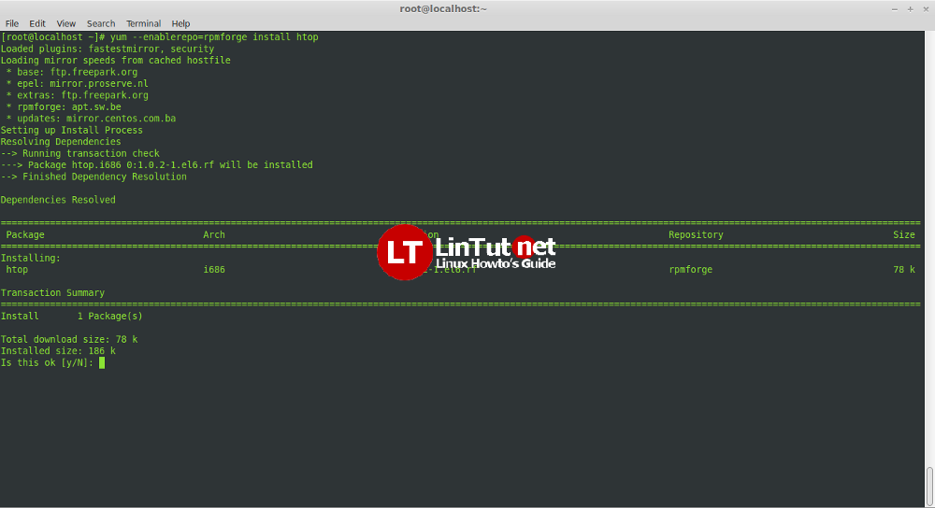

Disable RPMForge Repository in RHEL/CentOS 6/5/4
To disable RPMForge repository edit this file /etc/yum.repos.d/rpmforge.repo.
- # nano/etc/yum.repos.d/rpmforge.repo
Change “enabled=1” to “enabled=0“.

http://lintut.com/enable-epel-repository-on-centos-5-x6-x/

Enable Epel repository on CentOS 5.x/6.x
Posted by: rasho in Centos, Commands, Fedora, Linux 10/09/2013 1 Comment 104 Views
EPEL means Extra Packages for Enterprise Linux, these are some extra packages that are always needed and these are not included in the default installation of some Linux distributions, for example CentOS. Why is it related to Nginx? Because even this is not an official Nginx repo, it can provide differentNginx rpm alternatives to the one from the official Nginx repo.

How To Enable EPEL Repository in CentOS 5.x/6.x
First, you need to install wget.
- # yum install wget -y

RHEL/CentOS 5.x 32 Bit
- # wget http://download.fedoraproject.org/pub/epel/5/i386/epel-release-5-4.noarch.rpm
- # rpm -ivh epel-release-5-4.noarch.rpm

RHEL/CentOS 5.x 64 Bit
- # wget http://download.fedoraproject.org/pub/epel/5/x86_64/epel-release-5-4.noarch.rpm
- # rpm -ivh epel-release-5-4.noarch.rpm

RHEL/CentOS 6.x 32 Bit
- # wget http://download.fedoraproject.org/pub/epel/6/i386/epel-release-6-8.noarch.rpm
- # rpm -ivh epel-release-6-8.noarch.rpm

RHEL/CentOS 6.x 64 Bit
- # wget http://download.fedoraproject.org/pub/epel/6/x86_64/epel-release-6-8.noarch.rpm
- # rpm -ivh epel-release-6-8.noarch.rpm

Verify EPEL Repo
You need to run folowing command:
- # yum repolist
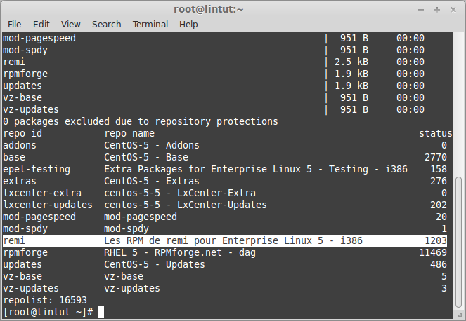
Verify epel repository sample output
Also check out Enable Remi repository on CentOS 5.x/6.x

http://lintut.com/enable-remi-repository-on-centos-5-x6-x/

Enable Remi repository on CentOS 5.x/6.x
Posted by: rasho in Centos, Commands, Linux 09/09/2013 1 Comment 53 Views
The following article will describe how to configure a CentOS 5.x-based or Centos 6.x-based system to useFedora Remi repository. These package repositories are not officially supported by CentOS, but they provide much more current versions of popular applications like PHP or MYSQL.

Install the extra repositories
The first step requires downloading some RPM files that contain the additional YUM repository definitions. The instructions below point to the 64-bit versions that work with our Cloud Server instances.
Centos 5.x
wget http://rpms.famillecollet.com/enterprise/remi-release-5.rpm
sudo rpm -Uvh remi-release-5*.rpm
Centos 6.x
wget http://rpms.famillecollet.com/enterprise/remi-release-6.rpm
sudo rpm -Uvh remi-release-6*.rpm
Once installed you should see some additional repo definitions under the /etc/yum.repos.d directory.
$ ls -1 /etc/yum.repos.d/remi.repo
/etc/yum.repos.d/remi.repo
Enable the remi repository
The remi repository provides a variety of up-to-date packages that are useful or are a requirement for many popular web-based services. That means it generally is not a bad idea to enable the remi repositories by default.
First, open the /etc/yum.repos.d/remi.repo repository file using a text editor of your choice:
sudo vim /etc/yum.repos.d/remi.repo
Edit the [remi] portion of the file so that the enabled option is set to 1. This will enable the remi repository.
name=Les RPM de remi pour Enterprise Linux $releasever - $basearch
#baseurl=http://rpms.famillecollet.com/enterprise/$releasever/remi/$basearch/
mirrorlist=http://rpms.famillecollet.com/enterprise/$releasever/remi/mirror
enabled=1
gpgcheck=1
gpgkey=file:///etc/pki/rpm-gpg/RPM-GPG-KEY-remi
failovermethod=priority
You will now have a larger array of yum repositories from which to install.
Also check out Enable Epel repository on CentOS 5.x/6.x

http://repoforge.org/use/

[root@ds-mon11t yum.repos.d]# rpm -Uvh /tmp/rpmforge-release-0.5.3-1.el6.rf.x86_64.rpm
warning: /tmp/rpmforge-release-0.5.3-1.el6.rf.x86_64.rpm: Header V3 DSA/SHA1 Signature, key ID 6b8d79e6: NOKEY
Preparing... ########################################### [100%]
1:rpmforge-release ########################################### [100%]
[root@ds-mon11t yum.repos.d]#

[root@ds-mon11t yum.repos.d]# cat rpmforge.repo
### Name: RPMforge RPM Repository for RHEL 6 - dag
### URL: http://rpmforge.net/
[rpmforge]
name = RHEL $releasever - RPMforge.net - dag
baseurl = http://apt.sw.be/redhat/el6/en/$basearch/rpmforge
mirrorlist = http://mirrorlist.repoforge.org/el6/mirrors-rpmforge
#mirrorlist = file:///etc/yum.repos.d/mirrors-rpmforge
enabled = 1
protect = 0
gpgkey = file:///etc/pki/rpm-gpg/RPM-GPG-KEY-rpmforge-dag
gpgcheck = 1

[rpmforge-extras]
name = RHEL $releasever - RPMforge.net - extras
baseurl = http://apt.sw.be/redhat/el6/en/$basearch/extras
mirrorlist = http://mirrorlist.repoforge.org/el6/mirrors-rpmforge-extras
#mirrorlist = file:///etc/yum.repos.d/mirrors-rpmforge-extras
enabled = 0
protect = 0
gpgkey = file:///etc/pki/rpm-gpg/RPM-GPG-KEY-rpmforge-dag
gpgcheck = 1

[rpmforge-testing]
name = RHEL $releasever - RPMforge.net - testing
baseurl = http://apt.sw.be/redhat/el6/en/$basearch/testing
mirrorlist = http://mirrorlist.repoforge.org/el6/mirrors-rpmforge-testing
#mirrorlist = file:///etc/yum.repos.d/mirrors-rpmforge-testing
enabled = 0
protect = 0
gpgkey = file:///etc/pki/rpm-gpg/RPM-GPG-KEY-rpmforge-dag
gpgcheck = 1
[root@ds-mon11t yum.repos.d]#

